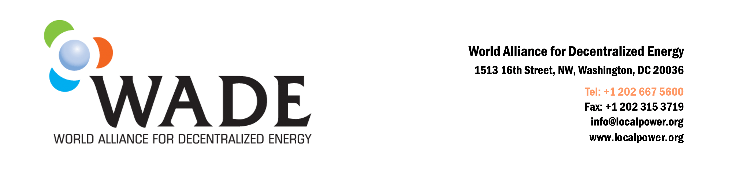

For immediate release
Contact: Sharada Gollu
Phone: 202 667 5600
Email: sgollu@localpower.org

New Report Highlights Potential for Clean Energy in China
Washington, DC – June 18, 2010 – The World Alliance for Decentralized Energy (WADE) has released a summary of a new report evaluating the potential benefits of combined heat and power (CHP) and clean distributed generation (DG) in China. The report was produced with support from the United States Department of State and the Asia-Pacific Partnership on Clean Development and Climate (APP), a seven-nation partnership formed to accelerate the development and deployment of clean energy technologies. APP members include Australia, Canada, China, India, Japan, Korea, and the United States.

The project is intended to develop policy options, action plans, and stakeholder commitment at the provincial level in China. Five target provinces/municipal districts - Shanghai, Liaoning, Shandong, Jiangsu, and Sichuan - were chosen for research based on a review of their fuel supply outlook, including natural gas, sustainable biomass and waste thermal sources, an assessment of overall economic growth and development, and an evaluation of the technical application potential for CHP.

“This report demonstrates how important the deployment of CHP and clean distributed energy can be for China,” said David Sweet, Executive Director of WADE. “It shows the tremendous potential for reducing greenhouse gases while at the same time reducing delivered power costs. This can be a win-win for the environment and the economy in China.” Deployment of CHP/DE can save energy and reduce CO₂ emissions by displacing coal-based central station generation with more efficient natural gas and waste fuel/waste heat CHP and distributed energy located at or close to the point of use.

An estimate for clean DE and CHP technical potential was developed for each target province/municipality using the best available industrial and commercial building data collected by the project team. The total technical potential for clean DE and CHP within the five target regions is estimated to be 143.7 gigawatts (GW) of electric generating capacity. This represents 38 percent of the 371.5 GW increase in central station generating capacity projected to be required in these five regions between 2010 and 2030.

The total energy savings resulting from full deployment of the 143.7 GW of CHP/DE potential in the four provinces and Shanghai amounts to about 6.3 billion GJ annually in 2030. Full deployment of CHP/DE would result in an overall energy reduction in the four provinces and Shanghai of 19 percent in 2030 compared to continued reliance on traditional central station power generation, and a total reduction in CO₂ emissions of 33 percent.

The WADE report concludes that development of customer-based CHP and clean decentralized energy can provide significant benefits in the four target provinces and Shanghai by displacing inefficient coal-based central station power generation with power produced from highly efficient natural gas CHP technologies and DE technologies fueled by waste heat and industrial and commercial waste fuels. “The WADE model provides a powerful tool to understand the economic and environmental benefits of distributed energy and combined heat and power,” said WADE Chairman Jim Crouse of Capstone Turbine Corporation.

The executive summary of the report can be found at http://www.localpower.org/WADE-APP-Summary.doc

The World Alliance for Decentralized Energy (WADE) works to accelerate the worldwide development of high efficiency cogeneration, onsite power and decentralized renewable energy systems that deliver substantial economic and environmental benefits. In an effort to raise the profile of cogeneration as a climate change mitigation strategy in the 1997 UNFCCC climate change negotiations, the International Cogeneration Alliance was founded. In 2002 the group changed its name to WADE and broadened its scope to include all manner of decentralized energy technologies. WADE is at www.localpower.org.

